Micro processor and Interfacing Lab Experiment

## Name: Om Ashish Mishra

## Registration Number: 16BCE0789

## Slot: B2

3. Fibonacci series

**ALP:**

.MODEL SMALL

.DATA

RES DB ?

CNT DB 0AH

.CODE

START: MOV AX,@DATA

MOV DS,AX

LEA SI,RES

MOV CL,CNT

MOV AX,00H

MOV BX,01H

L1:ADD AX,BX

DAA

MOV [SI],AX

MOV AX,BX

MOV BX,[SI]

INC SI

LOOP L1

INT 3H

END START

**Algorithm:**

1. We take to number of times the fibonaci series has to continue.
2. Then we initialize ax = 1 and bx=1 and res to store the result
3. After completing data segment we go for code segment
4. We run a loop where we add ax and bx
5. Put the value in source from ax
6. Put the value of ax in bx
7. Put the value of si into ax
8. Increase the value of si
9. Continue the loop
10. Thus terminate at the end and end the loop.

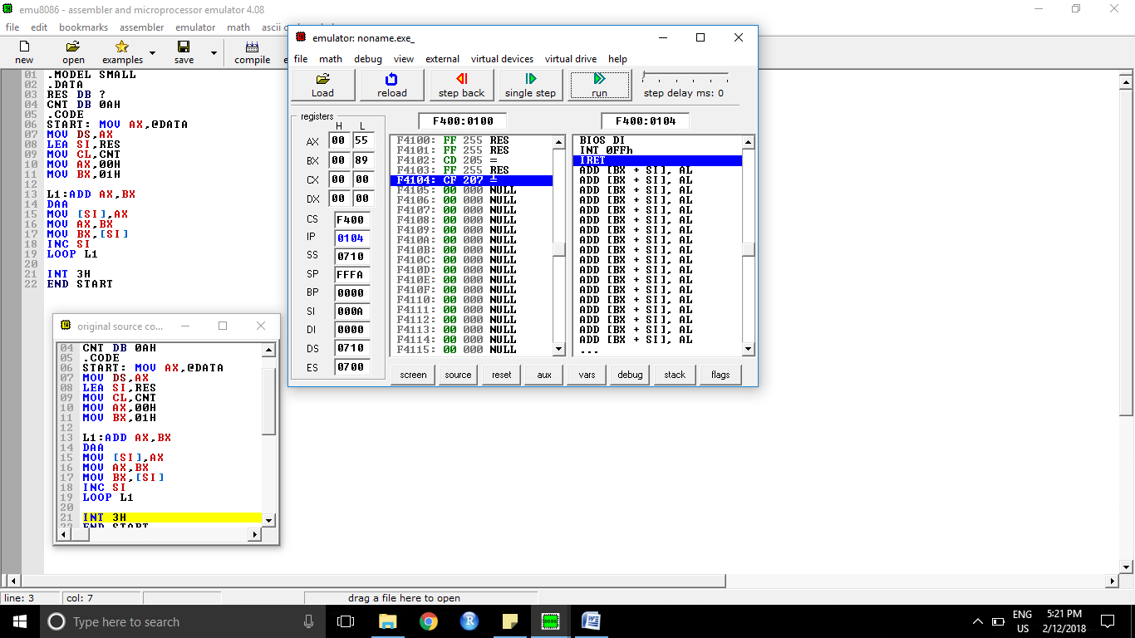

**Input Sample:**

10 is the number of times

**Output Sample:**

89 is the output.

**Result:**

The output of the Fibonacci series is 89h.